*Case study 4.3:* **Hands-off FCL using autoISF on Xmas** V.2.2



A *pre-release tester* reports here on trying, for a 5-day period in the 2023

Christmas season, a **completely hands-off** FCL utilization.

Method

FCL with (then not yet released) dev variant of AAPS 3.2.0.4 w/autoISF 3.0.1

Lyumjev 100 (DIA 7h) in Combo pump w/ 10mm Teflon cannula (0-48h)

2 x G6 overlapping (see case study 1.5; sensors used ~ d3 – d15; xDrip; no smoothing in AAPS)

profile basal ~ 14 U (0.41…0.75 U/h); profile_ISF 36…44 mg/dl/U (circadian);

TDD 43 U (which is above his normal TDD, see p.2).

Main settings for 24/7 adaptation of ISF **\*)**:

* SMB range extention and autoISFmax both = 2.9; SMB delivery ratio = 0.75 fixed
* bgAccel_ISF_weight = 0.24; pp_ISF_weight = 0.03; dura_ISF_weight 0.8
* iobTH_percent=60

**\*) Caution: Do not copy settings** from others,

not even for starting your tuning.

Why, see FCL e-book section 4.1.

**No user interference**:

* no boli
* no carb inputs
* no setting Eating Soon
* no “manual nudging” via the top fields in AAPS main screen (%profile, exercise, TT).

**Loop did use** **the following** **Automations** (from the initial FCL set-up, as described in FCL e-book)**:**

* *For meal management:* Automation that sets TT=74 mg/dl for 26m if delta>10 (FCL e-book section 2.5)
* *For nighttime management* “Adjunct Automations.” (discussed in FCL e-book section 5.1.2)*:*
  + Operate with an odd profile target at 3am-10am for default SMB shut-off…
  + …complemented by Automations to get temp. SMBs (if bg>160; iob<3.5) during nighttime
  + Note: If tester normally would do breakfasts, set odd profile TT would end earlier than 10 am
* **Activity monitor** 24/7 on. Scale factors 1.2 activity and 0.3 inactivity.

96% TIR (HbA1c ~ 5.6%) during 5 days at Christmas

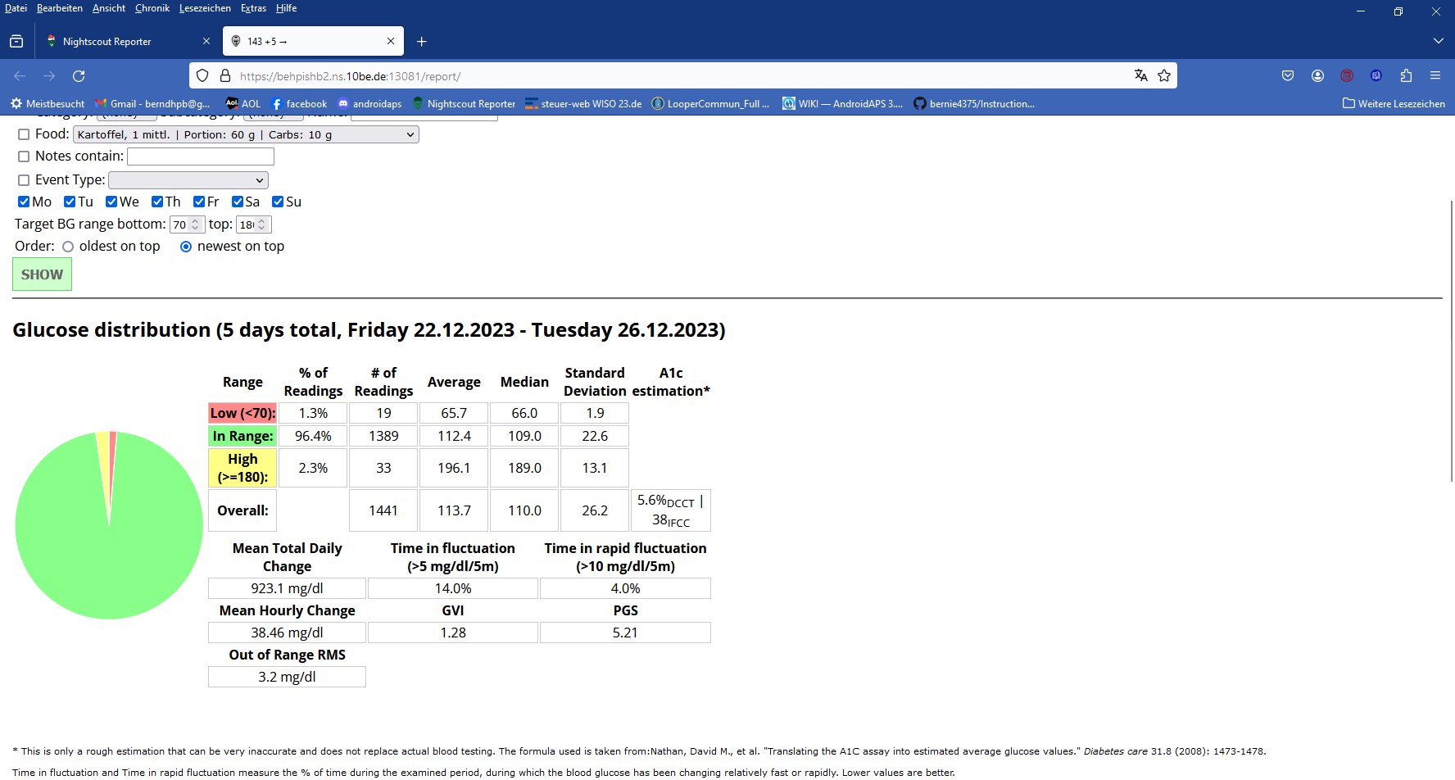

Negligable hypo tendency

The statistics for the “Low < 70 mg/dl” line of above table shows:

* Only 1.3 % of values were below 70 mg/dl
* Half of those (0.7%) were under the group-median of 66 mg/dl
* Virtually no data point below 62 mg/dl (= Median low minus 2 SD)(61 was lowest in Daily stats)

The percentile report shows, that briefly after midnight the low tendency is biggest (down regulation from dinner coincides with a last dogwalk):

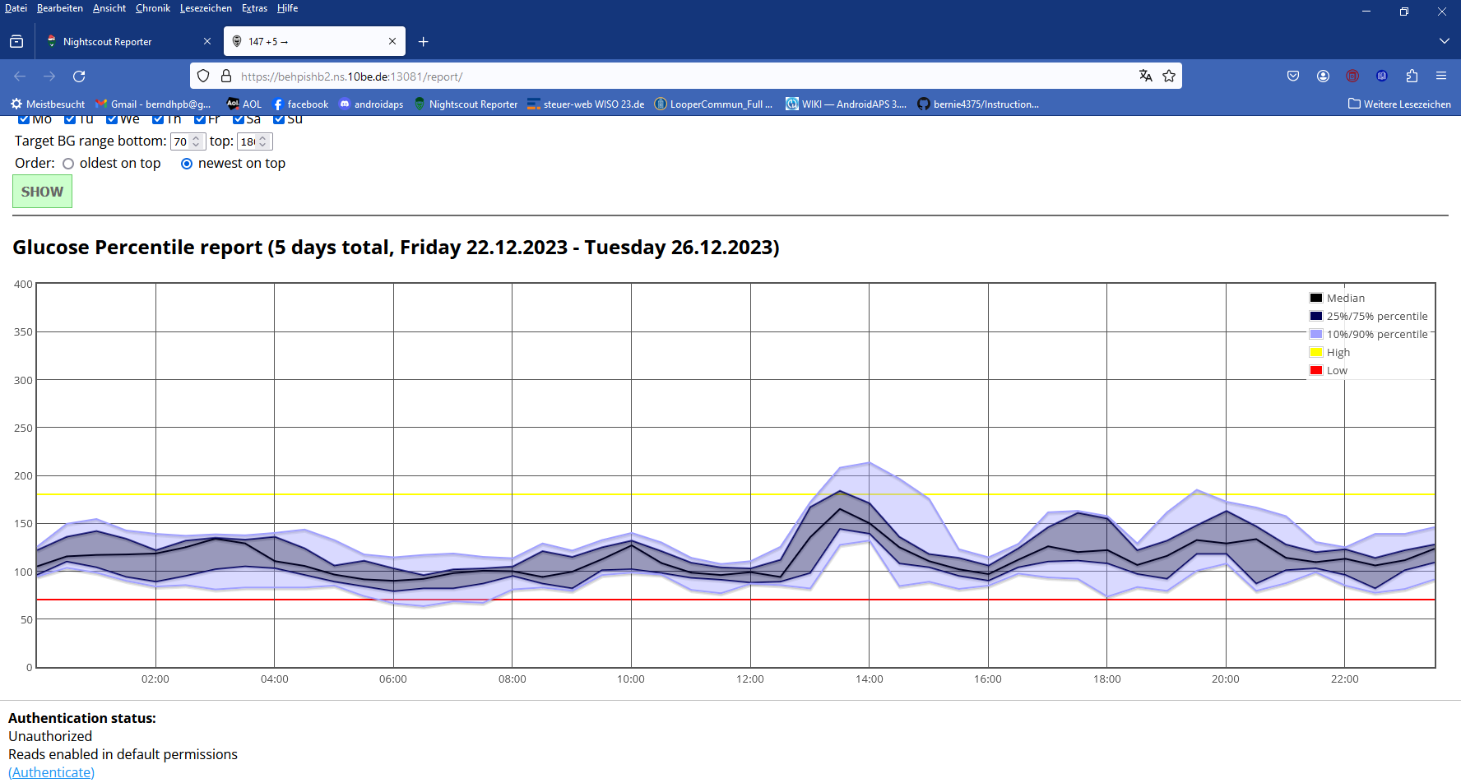

Details for each of the 5 included days:

Due to some **excessive eating**, TDD was on average 42.8 U (+16% to normal TDD averaging 37U). No big breakfasts. Dinners came relatively late; and once, on Dec 25/26th, there was midnight chocolate fondue w/ 2 gl. sweet hot wine (Glühwein)

Two very big holiday lunches (25th and 26th), goose resp. turkey, with dumplings, vegetables and small desserts; Christmas cookies. No settings were adjusted.

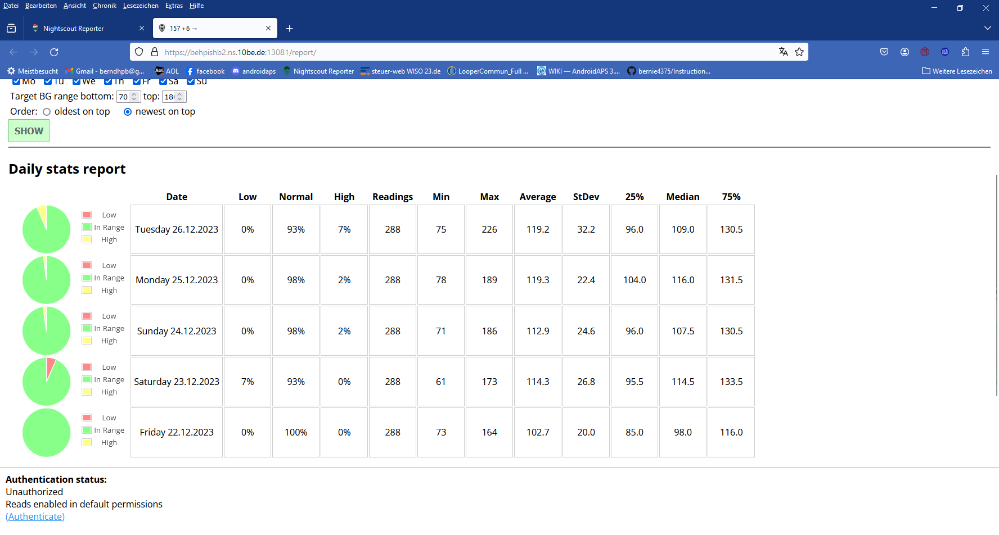

In the daily charts that follow, the SMB sizes are indicated (no bolus was ever given).

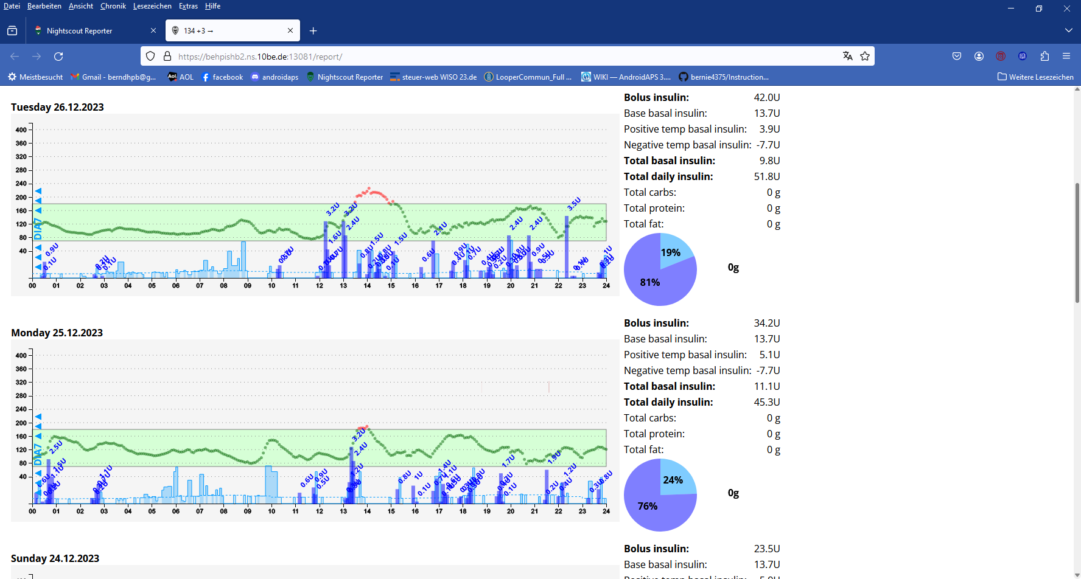

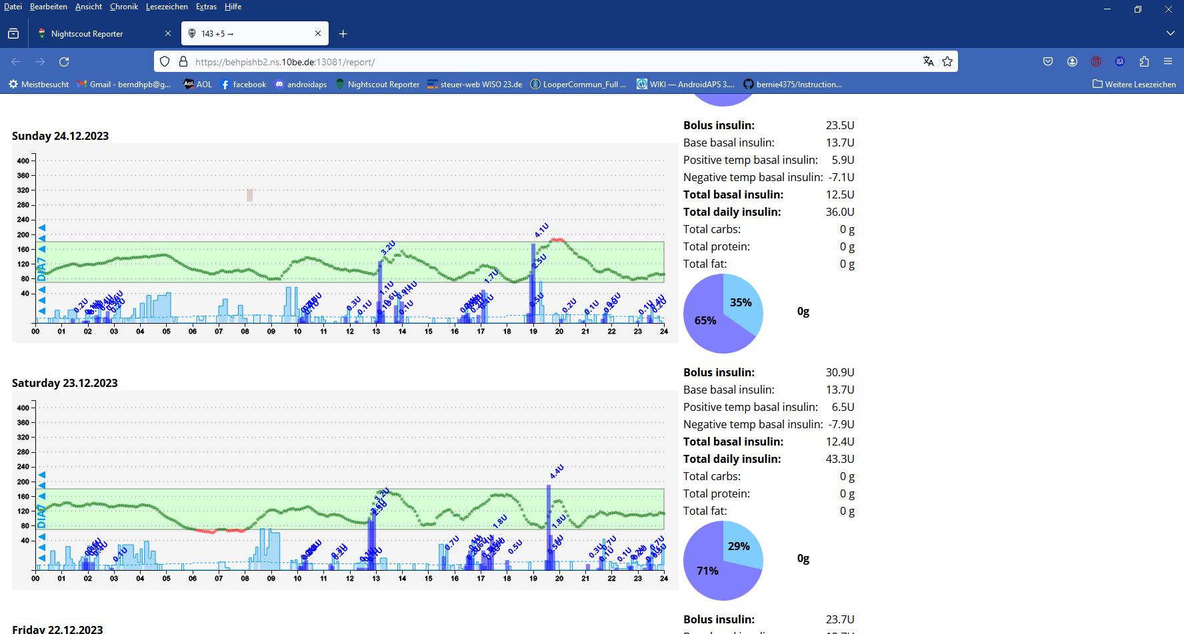



**Friday 22.12.2023** …

…was a 100% TIR day (chart not included)

Conclusions

The completely **hands-off** FCL worked very well on these days that were characterized by above-average food consumption, and no major exercise.

Going ~ 20% higher in carb intake was no problem for the sophisticated way autoISF auto-adapts to the predicted further glucose curves.

The new “**Activity monitor”** seemed sufficient to deal with automatic adjustments to frequent inactivity, as well as to several 30-45 minute daily dogwalks.

Discussion regarding limitations

The conclusions that can be drawn from this n=1 user experience rely on a well-run **initial tuning**. Also, the user’s diabetes, general health condition, lifestyle, and, notably, familiarity with the system, suggest he should reach better-than-average results.

Users should resist the temptations to “nudge”, be it with temporary settings or even by sometimes giving a bolus. Any such user action disturbs the workings of the autoISF loop and is – at least on average –unlikely to lead to further improved results.

What the user should still do, is:

* Look occasionally after **BT connectivity** (especially after meal starts)
* Look occasionally into the bg and iob (or insulin activity, thin yellow curve) development, and develop some “mindfulness” so to some extent, and only sometimes, this might influence the eating/**snacking habit** a bit.
* With very special “disturbances” the hands-off FCL runs into limitations.

Notably if the need for extra snacks shall be kept low, ahead of **exercise** it can be essential to take special precautions for limiting iob and to elevate the glucose target (as known from hybrid closed loop). See example in case study 6.2

* If more “serious” exercise would have been included, the tester would have used some form of “exercise announcement”, and/or would have required snacks to avert hypos.